Milestone 1: Automated Research Paper Retrieval and Dataset Preparation

1. Objective
The objective of this milestone is to automate the process of discovering relevant research papers based on a user-defined topic, download available open-access PDFs, and prepare a clean metadata dataset for further analysis.2. Environment Setup
A Python virtual environment was created to isolate project dependencies. Required libraries were installed to support API communication, file handling, and dataset preparation.
Key Libraries Used:
- requests – API communication
- python-dotenv – secure API key handling
- pandas – metadata dataset creation

3. Research Paper Search Phase
The system accepts a research topic as user input and queries the Semantic Scholar API to retrieve relevant academic papers programmatically. Paper metadata such as title, year, and URL is extracted.
This phase ensures that paper discovery is automated and reusable for any topic.
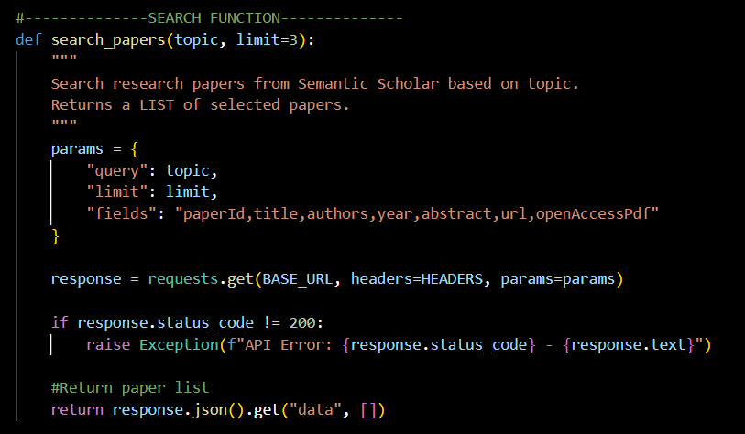

4. Paper Selection Phase
From the search results, a limited number of papers are selected based on Semantic Scholar’s relevance ranking. This approach ensures that the most relevant papers for the given topic are prioritized.
Selection criteria include:
- Valid paper title
- Publication year
- Semantic Scholar URL
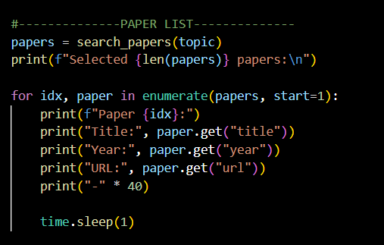

5. PDF Download Phase
For each selected paper, the system attempts to download the corresponding open-access PDF. Papers without publicly accessible PDFs are skipped gracefully to comply with licensing restrictions. Downloaded PDFs are stored locally in an organized directory structure.
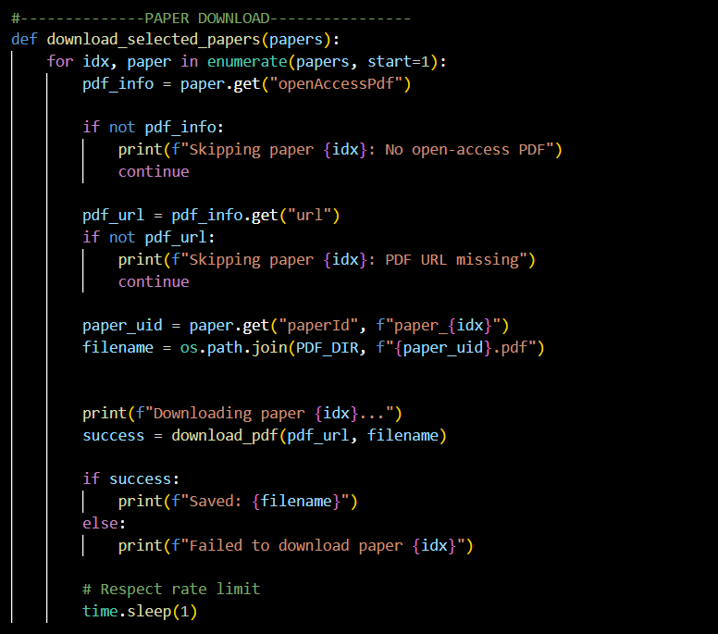

6. Metadata Dataset Preparation Phase
A structured metadata dataset is generated for all selected papers, regardless of PDF availability. The dataset includes bibliographic details, PDF availability status, and selection rationale.
This dataset acts as the foundation for subsequent analysis and summarization phases.
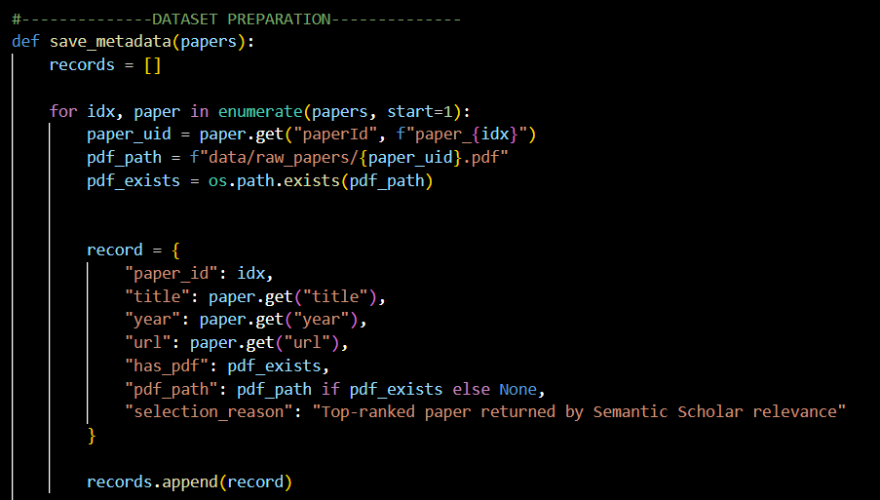

7. Outputs
At the end of this milestone, the system successfully:
- Accepts dynamic research topics
- Retrieves relevant research papers automatically
- Downloads available open-access PDFs and generates structured dataset.
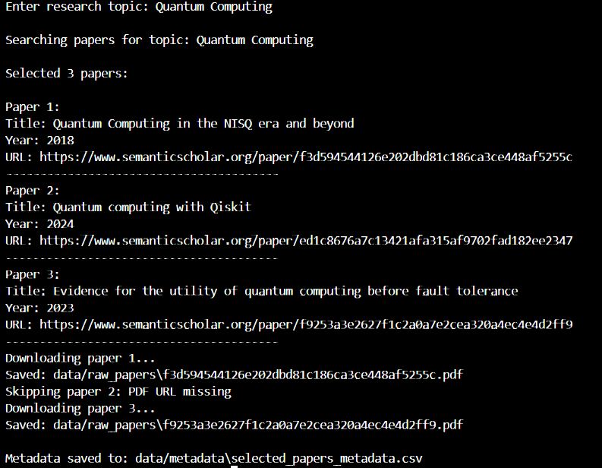

8. Conclusion
Milestone 1 establishes a reliable and automated pipeline for research paper retrieval and dataset preparation. The modular design ensures scalability and provides a strong foundation for further development in the next milestones.

